
College of Engineering, Construction and Living Sciences Bachelor of Information Technology
ID511001: Programming 2
Level 5, Credits 15
Theory Examination

Assessment overview
In this individual assessment, you will answer questions covering various taught concepts in this course. The main purpose of this assessment is to simulate a real-world take-home coding challenge and demonstrate your problem-solving ability within a short timeframe.

Learning outcomes
At the successful completion of this course, learners will be able to:
- Build interactive, event-driven GUI applications using pre-built components.
- Declare and implement user-defined classes using encapsulation, inheritance and polymorphism.

Condition of assessment
You will complete this assessment during your learner-managed time. This assessment will need to be completed by Wednesday, 20 November at 12.10 PM.

Pass criteria
This assessment is criterion-referenced (CRA) with a cumulative pass mark of 50% over all assessments in ID511001: Programming 2.

Authenticity
This assessment is open book. However, you are not permitted to use any AI tools, i.e., ChatGPT, Claude, GitHub Copilot, etc. In addition, do not discuss your theory examination answers with anyone during the short timeframe. Failure to do this will result in a mark of zero for this assessment.

Submission
You must submit your assessment via GitHub no later than Wednesday, 20 November at 12.10 PM.

Extensions
Extensions are not applicable for this assessment.

Resubmissions
Resubmissions are not applicable for this assessment.

Resits and reassessments
Resits and reassessments are not applicable for this assessment.

Start of the exam.

Short answer questions
- Explain the difference between public, private and protected access modifiers. For each access modifier, provide a supporting code example. (6 marks).

The public modifier can be accessed from anywhere and any place.
The Private modifier can only be accessed from itself.
And the protected modifier can only be accessed from itself or in something derived from itself.
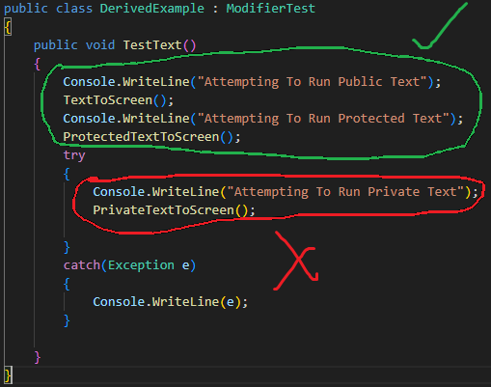
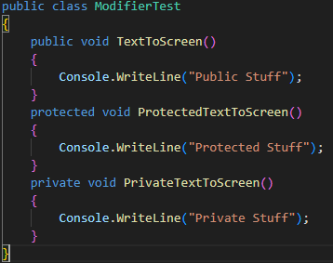
- Compile-time and run-time are two types of polymorphism. Explain the difference between the two types. For each type, provide a supporting code example. (5 marks).
Compile-time polymorphism is when you have multiple methods named the same with different parameters/ arguments inside the same class.
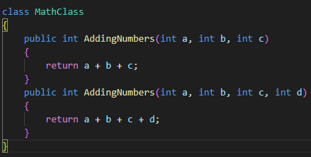
Run-time polymorphism is when you have a base class and derived classes with methods that are named the same but with different/overridden outputs.
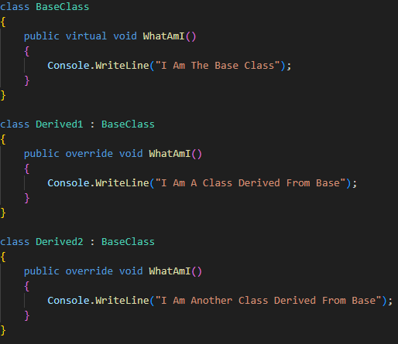
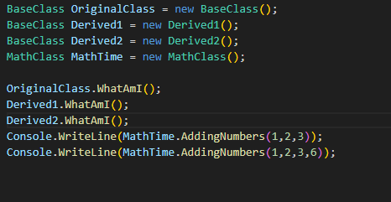
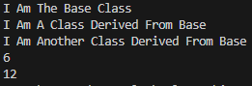
- Explain the difference between a class method and an instance method. For each method, provide a supporting code example. (5 marks).
Instance methods use instanced variables to have different outputs while class methods belong to the class itself not the instance and don’t access any instance variables.
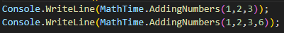
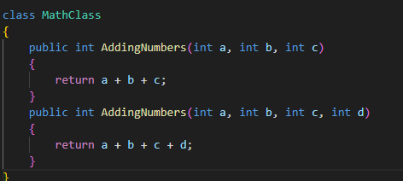

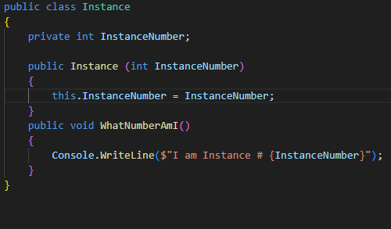
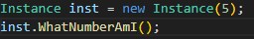

- Explain the base keyword in the context of inheritance. (2 marks).
The Base keyword means the original class that defines the basis of any derived classes.
- There are three errors in the following code. Explain the errors and how to fix them. (3 marks).

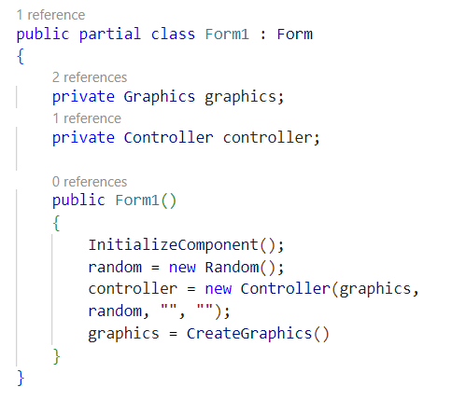
Error 1:
The random is created wrong should be:
Random random = new Random();
Error 2:
Graphics should be initialized before controller it should be:
graphics = CreateGraphics();
Controller = new Controller(graphics, random, “”, “”);
Error 3:
Forgot a semi colon at the end of CreateGraphics should be:
graphics = CreateGraphics();

- Explain the difference between a struct and a class. (4 marks).

- Explain what encapsulation is. Provide a supporting real-world example. (3 marks).

- Explain what an interface is. Provide a supporting code example. (3 marks).

- Explain two techniques or tools used for debugging code. (4 marks).

- Given the following enumeration. Write a line of code that parses the string “Saturday” to an enumeration value. (1 mark).
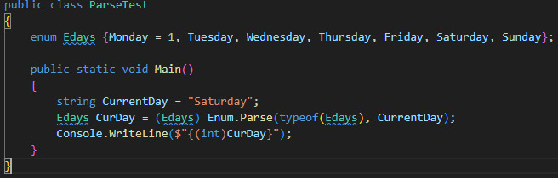

Programming questions

Task one:
In the assessment repository, you have been provided with an application called TaskOne. Once you have completed this task, add, commit and push your code to GitHub.
In the Person class:
  - Write a constructor that accepts a first name, last name, and age. (4 marks).
  - Write a property for first name, last name and age. (3 marks).
In the Form1 class:
  - Using the List<Person> people, write a LINQ query that returns a List<Person> where a person’s first name starts with “B”. (2 marks).
  - Write a foreach loop that displays the List<People> returned in 1.3 in the first list box. (2 marks).
  - Using the List<Person> people, write a LINQ query that returns a List<Person> where a person’s age is less than 18. (2 marks).
  - Write a foreach loop that displays the List<People> returned in 1.5 in the second list box. (2 marks).
Expected output:
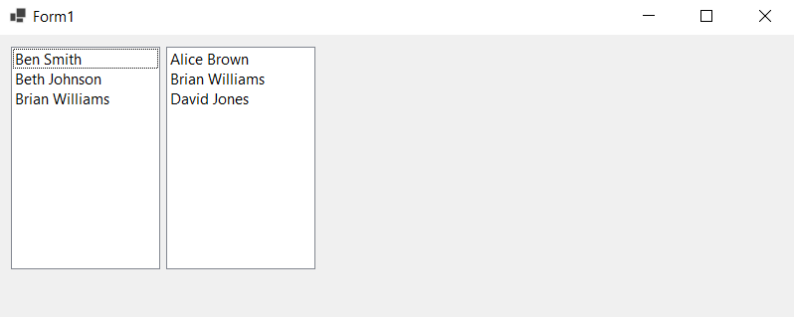

Task two:
In the assessment repository, you have been provided with an application called TaskTwo. Once you have completed this task, add, commit and push your code to GitHub.
In the Animal class:
  - Write two protected fields for name and age. (1 mark).
  - Write an abstract method that returns a string called Sound. (1 mark).
In the Cat class:
  - Write a constructor that is inherited from Animal. (1 mark).
  - Write an override method that returns a string “Meow!” called Sound. (1 mark).
In the Dog class:
  - Write a constructor that is inherited from Animal. (1 mark).
  - Write an override method that returns a string “Woof!” called Sound. (1 mark).
In the Form1 class:
  - Add two columns to the data grid view. The first column is name, and the second column is age. (2 marks).
  - Write a foreach loop that displays the name and age of each animal in the List<Animal> animals in the data grid view. (4 marks).
Expected output:
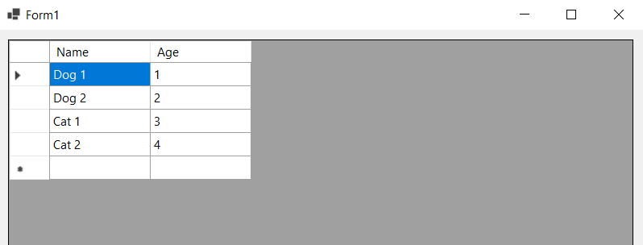

Task three:
In the assessment repository, you have been provided with an application called TaskThree. Once you have completed this task, add, commit and push your code to GitHub.
In the Form1 class:
- Using the DrawLine and DrawString methods, draw a grid with x and y coordinates. (6 marks).
- Using the FillRectangle and FillEllipse methods, draw a robot. The robot contains a head, eyes, mouth, body, arms and legs. (11 marks).
Note: Feel free to draw the robot anywhere on the grid.
Expected output:
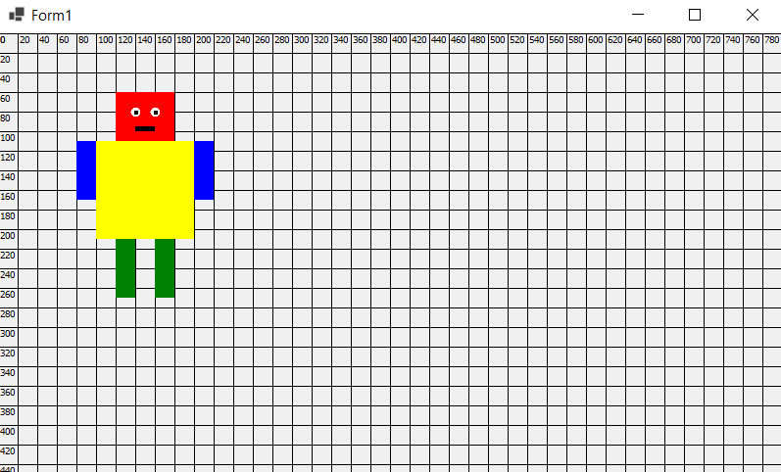

Task four:
In the assessment repository, you have been provided with an application called TaskFour. Once you have completed this task, add, commit and push your code to GitHub.
In the Form1 class:
- Write a method that accepts an integer and returns a bool called IsPrime. The method should determine whether the integer is a prime. (6 marks).
- In the button click method, generate ten random prime numbers between 1 and 1000, clear the list box and display the prime numbers in the list box. (4 marks).
Expected output:
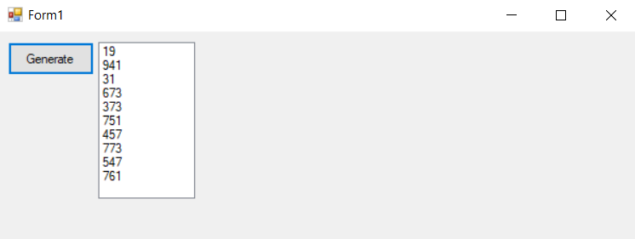
End of the exam.

